FSIA E-circular dt March 17, 2012

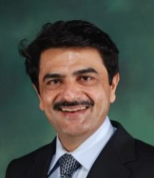  Rajive Chawla  President, FSIA |  |   Sangeet Kr Gupta  Hon. Consultant, FSIA

BUDGET 2012-13

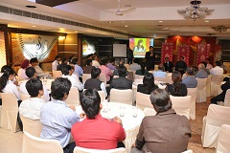 | 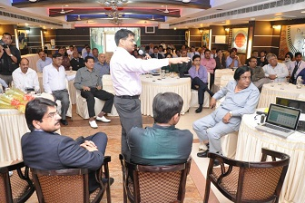

For the Fifth Consecutive Time in the history of Faridabad, we had an Instant and LIVE Budget Analysis, with a panel of Experts,

- We had Chartered Accountants from the Faridabad C.A. Branch of NIRC of Institute of Chartered Accountants of India, We also had the media, We had eminent Bankers, from Financial Institutions, including Mr Ajay Garg, Director of Corporation Bank. We had our own FSIA panel of Consultants. We had our own Mr Rajive Chawla, who later in the day was panel speaker and voice of SME at the CNBC, Zee Business TV Channel and many other TV channels
- And we had …….. the dynamic businessmen of Faridabad,.

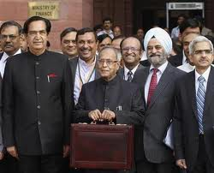 | It was Mr Pranab Mukherjee LIVE, via the Giant Television, in the Hotel Delite , before all the members of the FSIA | 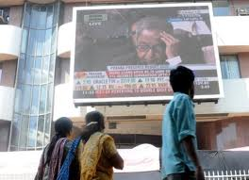  It was a successful FSIA event,  As always

Dear Members,

The Budget 2012 came in, on 15th March ( 15 days after the usual 28th Feb date, due to the UP and other state elections). Good LIVE discussions were done at Hotel Delite on 16.3.2012.
Now, many more finer nuances have become apparent in the fine print. More will be discovered in the coming days. But till then, some big points → and our FSIA analysis on → How they effect you ?
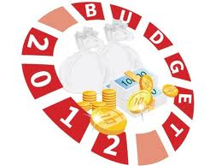

So, let us start our review
- Excise Rates and Service Tax = both “Big Change”
  - We all expected a change in rates. It has come now.
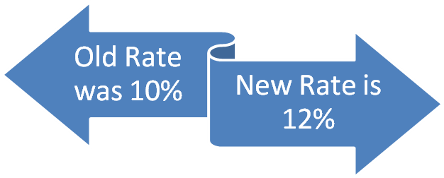
Effective Date for Excise = 17.3.2012, 00.01 am onwards
Effective Date for Service Tax Rate change = 01-04-2012 /

- Corporate Tax Rate
  - Quick reference chart is as under

Corporate Taxation
 | below 1 crores  of Profit | above 1 crores  of Profit
Basic Rate | 30.00 | 30.00
Surcharge 5% | - | 1.50
 | 30.00 | 31.50
Cess 3% | 0.90 | 0.95
 | 30.90 | 32.45

- Income Tax Rates changed, Small reduction for most Tax payers
  - Basic Slabs
Basic Rates |  | Rate
Upto Rs. 2,00,000 |  | Nil
Rs. 2.00 lac - Rs.5.00 lac |  | 10%
Rs. 5.00 lac - Rs.10.00 lac |  | 20%
Rs. 10.00 lac onwards |  | 30%
Surcharge |  | NIL
Education Cess , & SHE cess ( continues) |  |  | 3% for all.

  - No special limit for ladies, from now.
  - Basic exemption limit (till which, you do not have to pay any tax). This will be as follows :
    - For Gents : Rs. 2,00,000
    - For Ladies : Rs. 2,00,000 (same as gents)
    - For Senior Citizens : Rs. 2,50,000 ( 60 yr to 80 yr )
    - For Very Senior Citizens : Rs. 5,00,000 ( over 80 years )

  - So, ?? Most of you save a small value in Income TAXES =
    - Savings are upto Rs. 2060. per person for everybody and upto 22660 for people over Rs 10 lakh of income
    - See the chart below

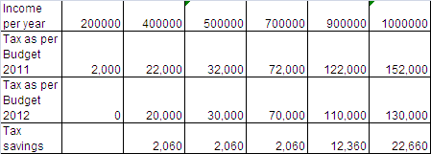
- So, Each one will save some Tax,
- And it could mean Rs 22660. per family member for many of us.
- And That is equal to say a Lakh of tax saving per family ,( assuming 4 earning members)
- And it also means on the reverse that you can have Rs 75000 of income more, per member, for the same tax .... ( Rs 3 lakh additional income !!! comes will zero additional tax )

Please observe == effective Tax Rates, have become further, very very low

Table 1 = Tax % has come down to very very low.

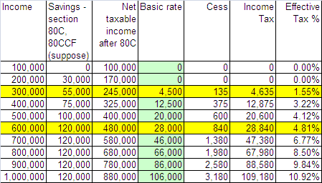

Note : We have “assumed” some savings in Section 80C, and new section 80CCF (infrastructure bonds ). Actual savings vary from person to person. And, please note, apart from this, you can take benefit of Mediclaim, HRA, conveyance allowance, and perks etc also.

Table 2 = TDS per month, has come down too, to pity amounts.

Above Table 2 is based on the Table 1 | Also, please see that a person who earns, say Rs. 41666 per month, has to pay TDS of just 1717 per month.  Similarly, for an Income of Rs. 25000 p.m. his tax could be just 386 p.m..  And for Income of 20000 p.m. his TDS could be just around Rs NIL / month
  Income | Tax reqd per month
  100,000 | 0
  200,000 | 0
  300,000 | 386
  500,000 | 1,717
  800,000 | 5,665
  1,000,000 | 9,098

- Biggest Surprise, the biggest happiness, the Marvelous pride of FSIA



Your FSIA was a part of “Creating the Budget Proposals” =
Giving Idea for this New Proposal

See this carefully

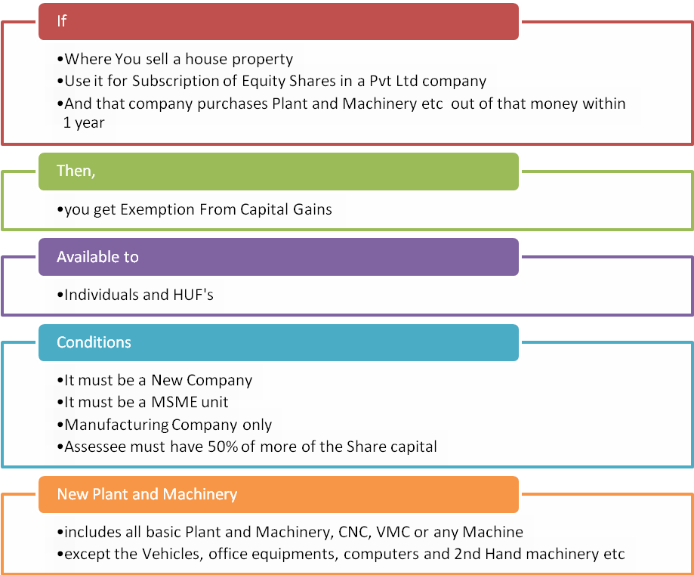
This will be a boon for every entrepreneur, who unlocks the value of his property and invests in his own business. Thank you FSIA thinkers.

- MAT ( Minimum Alternate Tax ) – Section 115 JB and 115 JC

  - What ? – It was a grouse of salaried / business people. They said, that we pay tax, but super large companies don’t pay tax. Similarly, people with business in Baddi, Rudrapur, Nalagarh, Daman/Diu(earlier), Sikkim, don’t pay tax. This was due to some deductions / exemptions, Now, They have been forced to pay heavier taxes.
  - And the rates are rising.
  - Have a look !!

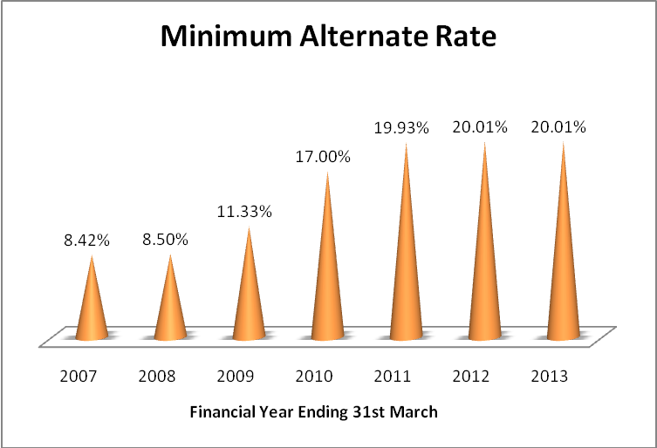

FSIA message
It is amusing but true that, we at FSIA had kind of predicted this coming, Note the language of section 115JC. This is exactly based on the language and tenor of the laws in USA. Infact even the MAT is now called AMT ( Alternate Minimum Tax = This is the same nomenclature as used by the Government of USA ).

For details, refer to our previous e circular on this subject. Click link below
http://www.finsys.co.in/ecirculars/073_FSIA_Ecircular_18th_Jan_2011_MAT_is_18percent+cess.pdf
in this circular we have mentioned some more things of USA income tax vs Indian Income tax, maybe they also could be creeping in….

Who will pay the MAT ( Minimum Alternate Tax ) ?

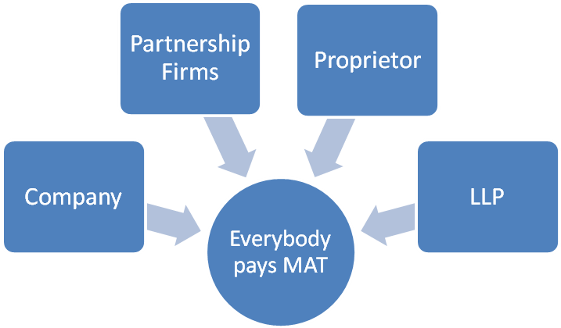
So, it is equal to all ….

This is First time in India, Never in last 50 years, this thing was required for “individuals”
Only small solace is that , individuals for income below Rs 20 lakhs will not be covered in this MAT. And second the rate for individuals is a shade less.
Individuals MAT rate is 19.055 % ( including basic + cess)
Whereas for companies MAT it is 20.1 % ( incl surcharge too)


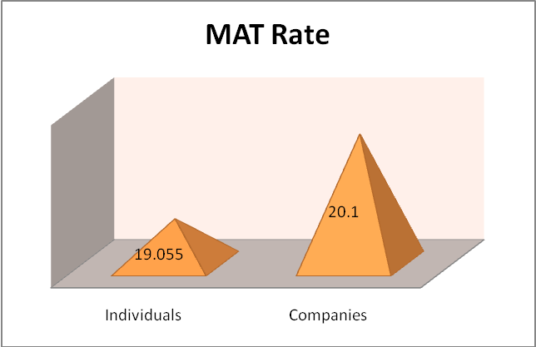

India is becoming USA, … atleast in Taxation

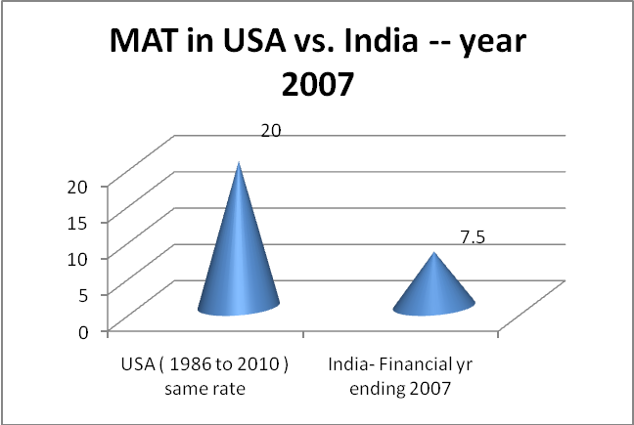

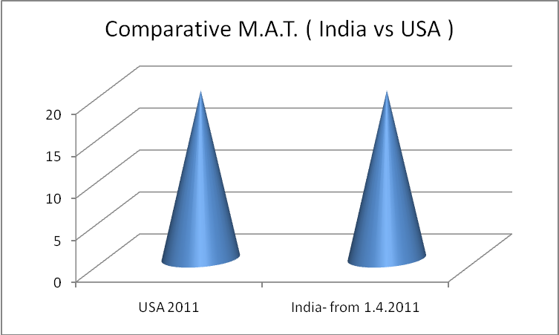

So, we are same

Cheers !!!

- Baddi and Rudrapur : Bubble Burst
  - Suddenly = MAT is yes ( same 20.01% )
  - Suddenly for last 2 years, SEZ is booo……
  - Now, Baddi plants are also going to be less lucrative.

- Gain to IMT Faridabad . . .

  - and all the Industrial sectors in Faridabad, Palwal, Noida, Manesar Gurgaon, and all normal locations.
  - Idea= Why go so far . . .when you are taxable anyway ??

- TDS on Sale of Immovable Property

Govt says, “This is a measure for black money management.”
So, If you sell any property, your buyer will deduct a TDS of 1 percent

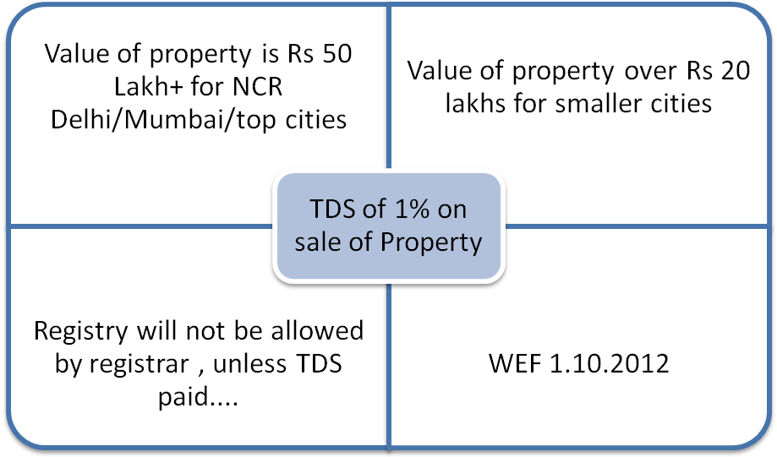
Yes, Faridabad, Gurgaon, Sonepat, Noida, Gaziabad, Loni etc are a part of the Delhi NCR

Final Message from the FSIA Team
India is growing at 17% ( GDP-Current prices ).
We are a part of this growth Story. Come our Time is now.
As somebody said at the C I I Meeting last year,

“It was always good to be born in India, But, mark my words .…..
This is the best time to be in India”.
Source Economic Survey 2011
Govt of India. Click here
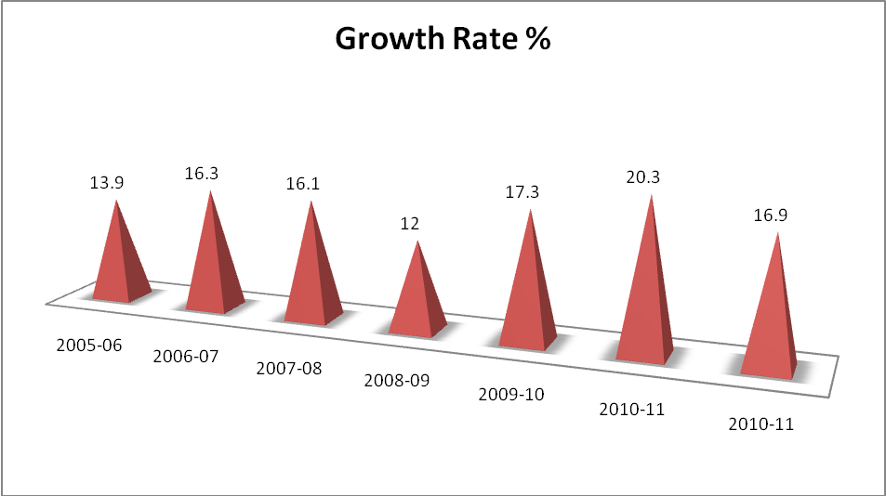
GDP Growth % (at Current Prices)

For queries, suggestions and feedback , you can e-mail us at :

Sangeet Kumar Gupta  FCA, ICWA, PGDMM, B.Com(Hons)  Honorary Consultant,  Faridabad Small Industries Association  93126-08426  groupmlg@eth.net  Camp Off : SCF no 70, Sector-16A Market, Faridabad  FSIA Off : FSIA Park, Opp. Plot No.23, Sector- 24,Faridabad- 121005 | 

Subscription
Please send your details, and request e-mail to fsiaindia@gmail.com or skgupta@finsys.in

for Discontinuation of this E-mail
To discontinue receipt of e-mails from the author, please reply mentioning "Discontinue" in the Subject.

Notes & disclaimer
For private circulation. Intended for recipient only. This is only for personal information of the members. Based on information & interpretations available as on Saturday, March 17, 2012. Please contact your Consultant / Chartered Accountant / counsel for his final opinion, if deemed fit.

Advt. : Many Successful businesses are controlling their Business operations, Accounts, Purchase, Sales, Complaints, Collections, Taxation, Production, QA, ISO-9000/ ISO-14001 and TS-16949 processes on the Finsys ERP packages © Finsys Infotech Limited 1992-2012.

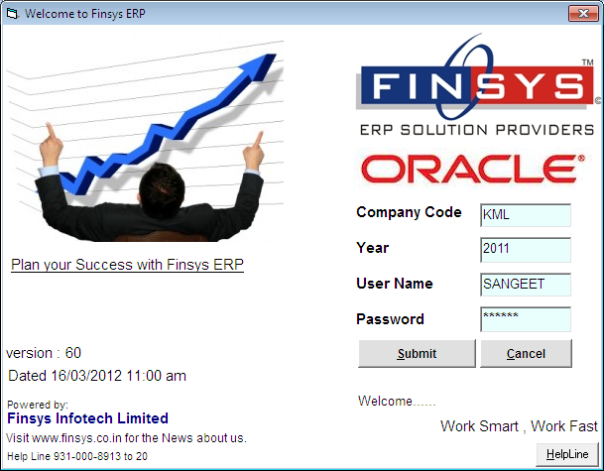

Last month to start the ERP Implementations, Contact us, for details, on how to make your ERP implementation better.

